ANGLEŠČINA 8. RAZRED, 5. TEDEN ( 14. 4. – 17. 4. 2020)
Hello! We are in week 5 and you are doing great so far! This week is shorter due to Easter Monday and sports day on Friday so you won't have to work very hard.
Let's get started!

Rešite delovni list (lahko si natisnete ali rešite v zvezek).
Ta teden ne rabite pošiljat rešenih listov, vam bova pri nalogah naslednjega tedna pripeli rešitve, da si boste sami pregledali!

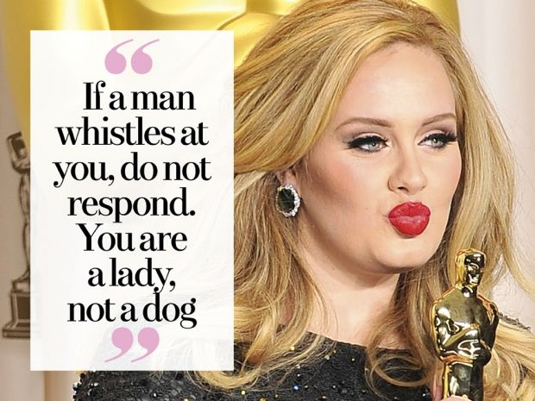
ADELE – BIOGRAPHY

Search the Internet for the answer to the first three questions.
Answer the questions in full sentences. The words in bold are the key words

- What is the full name of Adele?
___________________________________________________________________
- When and where was Adele born?
_________________________________________________________________.

Complete this sentence:

- When Adele was very young her ______________________________ left his family and Adele grew up with her ________________________ .
GRAMMAR

Write the verbs in brackets in the past simple tense.

- Her first album, 19, _____________ (be) released in 2008. Adele __________ (be) only 19 years old.

- In 2011, Adele ___________________(undergo) a throat operation which her doctor _____________________(blame) on her smoking habit.

- In 2011, she ______________(begin) dating Simon Konecki, and in October 2012, Adele ________________(give) birth to their son.

- His name is Angelo and he ___________ _______________ (be born) on 19 October 2012.

- Adele ___________________ (compose) and _________________(perform) the title track for the 2012 James Bond film Skyfall. Adele __________________(can not) promote the song because she _________________(be) heavily pregnant with her son at the time.

- In 2013 Adele __________________(win) an Oscar for her work on the song “Skyfall”, the main song of the James Bond’s movie “Skyfall”.

- In 2015 Adele _________________ (launch) her third album, 25. The main song of this album ______________ (be) “Hello”.

V kolikor še nimate rešene strani 44 v DZ, naredite še to ta teden.
Happy Easter and stay well!
Your English teacher

